Bahria University,

Karachi Campus

LAB EXPERIMENT NO.

**03**

LIST OF TASKS

|  |  |
| --- | --- |
| TASK NO | OBJECTIVE |
|  | **Set Operations and Joins** |
|  | Display Product’s name and their supplier’s name (ContactName), whose supplier’s name doesnot contain Dirk and there should be at most 7 characters in Product’s name. |
| 2 | Create a report showing order ID. OrderDate. EmployeeID, and the firstname and LastName of the associated Employee (Tables: Employees & Orders ) |
| 3 | List distinct cities from of customers and suppliers, country must be Germany. |
| 4 | **:** List all cities (duplicate values allowed)from of customers and suppliers |
| 5 | lists all customers and suppliers (ContactName, City, Country). |

Submitted On:

**16 – 3 – 2023**

(Date: DD/MM/YY)

**Task No. 1:** Display Product’s name and their supplier’s name (ContactName), whose supplier’s name doesnot contain Dirk and there should be at most 7 characters in Product’s name.

**Solution:**

select A.ProductName,B.ContactName from Products as A inner join Suppliers as B

on A.SupplierID=B.SupplierID where B.ContactName not like'dirk' and len(A.ProductName)<=7

**Output:**

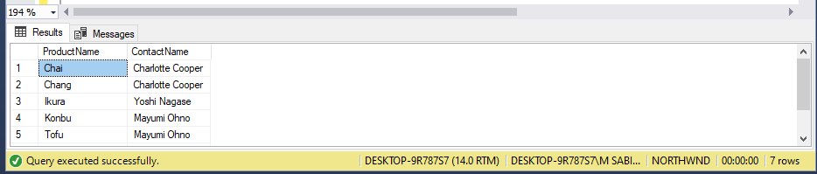

**Task No. 2:** Create a report showing order ID. OrderDate. EmployeeID, and the firstname and LastName of the associated Employee (Tables: Employees & Orders )

**Solution:**

select B.OrderID,B.OrderDate,A.EmployeeID,A.FirstName,A.LastName,A.FirstName+' '+A.LastName as [Full Name] from

Employees as A inner join Orders as B on A.EmployeeID=B.EmployeeID

**Output:**

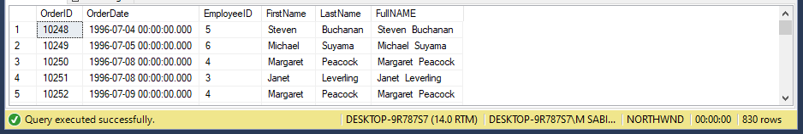

**Task No. 3:** List distinct cities from of customers and suppliers, country must be Germany.

**Solution:**

select distinct city from Customers where Country='germany'

union select distinct city from Suppliers where Country='germany'

**Output:**

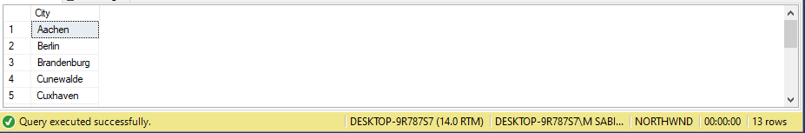

**Task No. 4:** List all cities (duplicate values allowed)from of customers and suppliers

**Solution:**

SELECT City FROM Customers UNION ALL

SELECT City FROM Suppliers

**Output:**

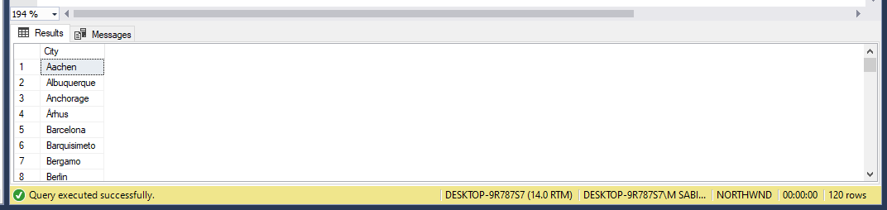

**Task No. 5:** lists all customers and suppliers (ContactName, City, Country)

**Solution:**

select ContactName, city,Country from Customers union select ContactName, city,Country from Suppliers.

**Output:**

